Assignment 5

- Create a char pointer and initialize it to point at the first element of the array. Dereference the pointer and describe what results you obtain and why.
A - Initialize a char pointer to the first element of the array and dereference it. I got only first char that is 0 in my case. This is because integer is 4 bytes but char cover only 1 byte the first character value.
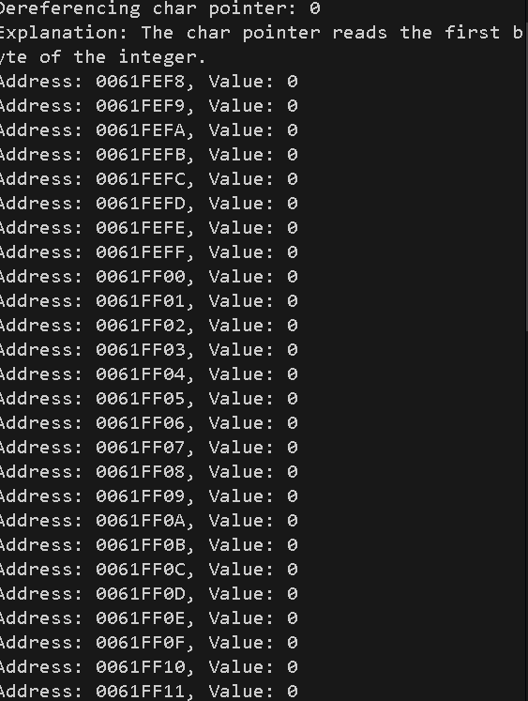

- Create an int pointer and initialize it to point at the first element of the array. Dereference the pointer and describe what results you obtain and why.
A - Initialize an int pointer to the first element of the array and dereference it. Got the first element as pointer matches the array element.
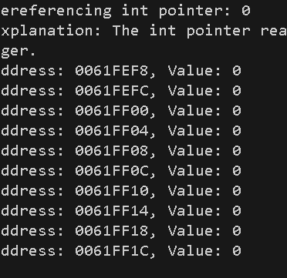

- Walk the char and int pointers through the array and describe the increments for each and why they differ.
A - Increment a char pointer, it moves one byte at a time. On the other hand, the int pointer moves by the int size, which is 4 bytes(32-bit) at a time. That’s why the address has 4 bytes difference.
- Walk the pointers beyond the end of the array and describe your results.
A—It gives me a garbage value. After my 4-byte increment, it provides a negative address as it reaches the array's out-of-bounds limit.

